1.

(1) Biomedical: the knowledge graph in healthcare use knowledge reasoning which is similar to causal inference. For informatics work such as finding adverse events or risk factors for disease using electronic health records.

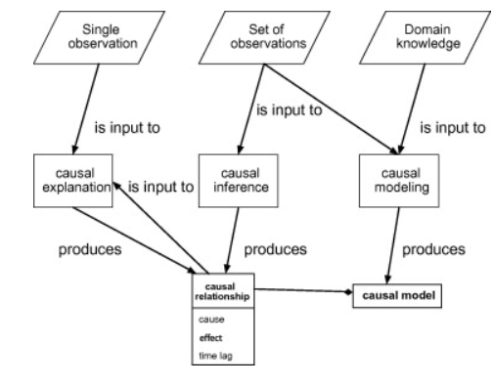

(2) Education:

(3) Economics

2.

3.

cold -> offline; cold -> online; online??offline; we cannot simply say cold is the causation of boost in consumption

cold weather -> Christmas -> spend more money.

4.

The successful rate of all cases. If don’t know the case distribution; otherwise, second one

5.

(1) 1/36

(2) ½

(3) ½

(4)1/6

(5) 11/36

(6) ¾

6.

7.

8.

10.

(1) w, y

(2) x, w, y

(3) y, z

(4) y, z, t

(5)x-y-t, x-y-z-t, x-w-y-z-t, x-w-z-t, x-w-y-z-t

11.

(1) p0 \* (1-p) \* q \* (1-p)

(2) (1-q+p) \*q

(3) ((1-q+p) \*q\*p0) /(p^2q+p(q-2q^2)+(q^3-q^2+q)+p0(p-q)^3)

(4) (p^2q+p(q-q^2))/ (p^2q+p(q-2q^2)+(q^3-q^2+q))